Experiment 5

Harsh-2401010096

Aim:

EMPLOYEES (Employee_Id, First_Name, Last_Name, Email, Phone_Number, Hire_Date, Job_Id, Salary, Commission_Act, Manager_Id, Department_Id)

Code:
CREATE database emp; use emp;

CREATE TABLE EMPLOYEES (
Employee_Id INT PRIMARY KEY, First_Name VARCHAR(50),
Last_Name VARCHAR(50), Email VARCHAR(100),
Phone_Number VARCHAR(20), Hire_Date DATE,
Job_Id VARCHAR(20),
Salary INT,
Commission_Act DECIMAL(5,2), Manager_Id INT,
Department_Id INT
);

INSERT INTO EMPLOYEES VALUES
(101, 'John', 'Smith', 'john.smith@email.com', '9876543210', '2020-01-15', 'IT_PROG',

6000, NULL, 100, 60),
(102, 'Sara', 'Connor', 'sara.connor@email.com', '9876543211', '2019-03-10', 'HR_REP',

4500, NULL, 101, 70),
(103, 'Mike', 'Austin', 'mike.austin@email.com', '9876543212', '2021-06-20', 'SA_REP',
5000, 0.10, 100, 80),
(104, 'Emma', 'Watson', 'emma.watson@email.com', '9876543213', '2018-11-05',

'IT_PROG', 7000, NULL, 101, 60),
(105, 'Liam', 'Brown', 'liam.brown@email.com', '9876543214', '2022-02-18', 'SA_REP',
4800, 0.15, 102, 80),

(106, 'Olivia', 'Davis', 'olivia.davis@email.com', '9876543215', '2020-07-25', 'HR_REP',

4200, NULL, 101, 70),
(107, 'Noah', 'Wilson', 'noah.wilson@email.com', '9876543216', '2017-09-30', 'IT_PROG',

8000, NULL, 100, 60),
(108, 'Ava', 'Taylor', 'ava.taylor@email.com', '9876543217', '2019-12-11', 'SA_REP', 4700,
0.12, 102, 80),
(109, 'Ethan', 'Anderson', 'ethan.anderson@email.com', '9876543218', '2021-04-14',

'IT_PROG', 5200, NULL, 101, 60),
(110, 'Sophia', 'Thomas', 'sophia.thomas@email.com', '9876543219', '2018-08-19',

'HR_REP', 4600, NULL, 100, 70),
(111, 'James', 'Jackson', 'james.jackson@email.com', '9876543220', '2020-05-23',

'SA_REP', 4900, 0.20, 102, 80),
(112, 'Isabella', 'White', 'isabella.white@email.com', '9876543221', '2019-01-30',

'IT_PROG', 6100, NULL, 101, 60),
(113, 'Lucas', 'Harris', 'lucas.harris@email.com', '9876543222', '2022-03-12', 'HR_REP',

4300, NULL, 100, 70),
(114, 'Mia', 'Martin', 'mia.martin@email.com', '9876543223', '2021-10-07', 'SA_REP',
5100, 0.18, 102, 80),
(115, 'William', 'Austin', 'william.austin@email.com', '9876543224', '2020-12-01',
'IT_PROG', 7500, NULL, 100, 60);

Find out the employee id, names, salaries of all the employees
SELECT Employee_Id, First_Name, Last_Name, Salary FROM EMPLOYEES;

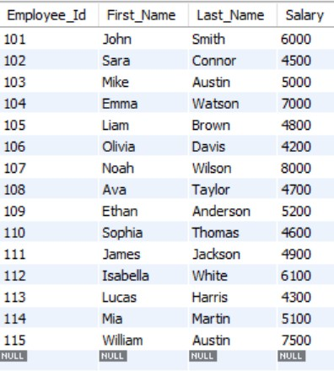

List out the employees who works under manager 100

SELECT *
FROM EMPLOYEES
WHERE Manager_Id = 100;

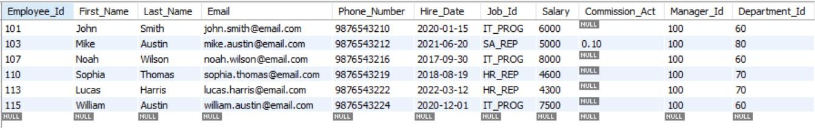

Find the names of the employees who have a salary greater than or equal to 4800
SELECT First_Name, Last_Name FROM EMPLOYEES
WHERE Salary >= 4800;
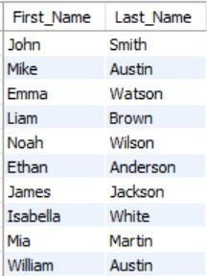

List out the employees whose last name is ‘AUSTIN’

SELECT *
FROM EMPLOYEES
WHERE Last_Name = 'AUSTIN';

Find the names of the employees who works in departments 60,70 and 80
SELECT First_Name, Last_Name FROM EMPLOYEES
WHERE Department_Id IN (60, 70, 80);
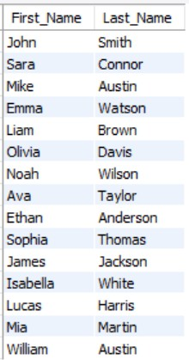
( f ) Display the unique Manager_Id. SELECT DISTINCT Manager_Id FROM EMPLOYEES;
